Call for Proposals
Mountains of Central Asia Biodiversity Hotspot

Small Grants

Eligible Countries: Kyrgyz Republic

Opening Date: Monday, 16 March 2020

Closing Date: Monday, 20 April 2020

Grant Size: Maximum amount US $20,000

WWF Central Asia serving as the regional implementation team for the hotspot, is accepting letters of inquiry (LOIs) from non-government organizations, community groups, cultural organizations, women’s groups, private companies and other civil society organizations for projects per the requirements listed here.

BACKGROUND

The Critical Ecosystem Partnership Fund (CEPF) is a joint initiative of l’Agence Française de Développement, Conservation International, the European Union, the Global Environment Facility, the Government of Japan and the World Bank. A fundamental goal is to ensure civil society is engaged in biodiversity conservation.

The Mountains of Central Asia Biodiversity Hotspot consists of two of Asia's major mountain ranges, the Pamir and the Tien Shan. Politically, the hotspot’s 860,000 square kilometers include southern Kazakhstan, most of Kyrgyzstan and Tajikistan, eastern Uzbekistan, western China, northeastern Afghanistan, and a small part of Turkmenistan. CEPF’s investment focuses on Key Biodiversity Areas (KBAs), defined as “sites contributing significantly to the global persistence of biodiversity”, as well as priority species and corridors.

WWF Central Asia serves as the Regional Implementation Team (RIT) and manages a small grant program to support projects up to $20,000. Recipients of small grants will receive agreements from WWF reflecting the requirements of CEPF.

Applicants are strongly encouraged to familiarize themselves with the RIT website, www.mca.earth and the CEPF website, particularly the sections on Eligibility and Before You Apply.

ELIGIBLE APPLICANTS

Non-governmental and non-commercial civil society organizations, registered community groups and citizen cooperatives, and private universities may apply for funding. It is possible for commercial organizations, such as farms and to apply for funding by special consideration. Individuals must work with civil society organizations rather than apply directly.

International organizations are encouraged to involve local organizations or communities as project partners and/or explain how local stakeholders will be engaged as part of project implementation.

Organizations must have their own bank account and be authorized under relevant national laws to receive charitable contributions. Groups without a USD bank account may partner with other organizations that do have a USD bank account.

Government-owned enterprises or institutions are eligible only if they can demonstrate that the enterprise or institution has:

- a legal personality independent of any government agency or actor;
- the authority to apply for and receive private funds; and
- may not assert a claim of sovereign immunity.

Grants cannot be used for:

- the purchase of land, involuntary resettlement of people, or activities that negatively affect physical cultural resources, including those important to local communities.
- activities adversely affecting indigenous peoples or where these communities have not provided their broad support to the project activities.
- removal or alteration of any physical cultural property (includes sites having archaeological, paleontological, historical, religious, or unique natural values).

PRIORITY ACTIVITIES AND GEOGRAPHIC AREAS

Grant funded through this solicitation will address one or more of the following themes:

- Local traditions and modern environmental education as the basis of sustainable development of local communities and natural ecosystems.
- Enhancement protection and monitoring of existing PA’s as an integrated unit.
- Conservation in KBAs as a basis for sustainable development in the most populated and productive valleys in the Kyrgyz Republic.

Projects should be organized to address the strategic directions and investment priorities in the table below and also described in pages 123 – 137 of the Ecosystem Profile.

Strategic direction | Investment priorities
1. Address threats to priority species | 1.5. Maintain populations of priority species beyond  those solely affected by collection, hunting, fishing,  poisoning, and nature users
Strategic direction | Investment priorities
2. Improve management of priority sites with and without official protection status | 2.1. Facilitate effective collaboration among CSOs, local communities, and park management units to enhance protected area networks
 | 2.2. Develop and implement management approaches to sustainable use in KBAs outside official protected areas
Strategic direction | Investment priorities
5. Enhance civil society capacity for effective conservation action | 5.1. Enable and enhance communication and collaboration between civil society and communities and government agencies responsible for implementing national biodiversity strategies
 | 5.5. Support action-oriented environmental education

Projects should address any of the following priority geographies:

- Corridor 7: Turkestan and Alai Mountains
- Corridor 18: Khan-Tengri and Tomur Mountains
- Key Biodiversity Area (KBA) 20: Isfairam-Shakhimardan
- KBA 23: Alai-Kuu
- KBA 28: Kumtor and Sarychat-Ertash
- KBA 30: Sary-Djaz

Regarding KBA 20, in particular, we expect proposals on enforcement and sustainable use of the juniper forest ecosystems, uncultivated areas, and endemic species, with participation of local resource users.

Regarding KBA 23, in particular, we expect proposals on endemic and endangered species protection and research, involvement of local resource users, and capacity building for effective KBA functioning.

The RIT will accept proposals that partially take place outside of these named priority KBAs and corridors if the project otherwise fulfils priorities listed in the Ecosystem Profile.

Priority will be given to projects that do not compete with existing projects on individual species. Instead, preference will be given to those projects that focus on larger ecosystem conservation surrounding a KBA or corridor, that replicate proven past methods, and build collaboratively on the work of others.

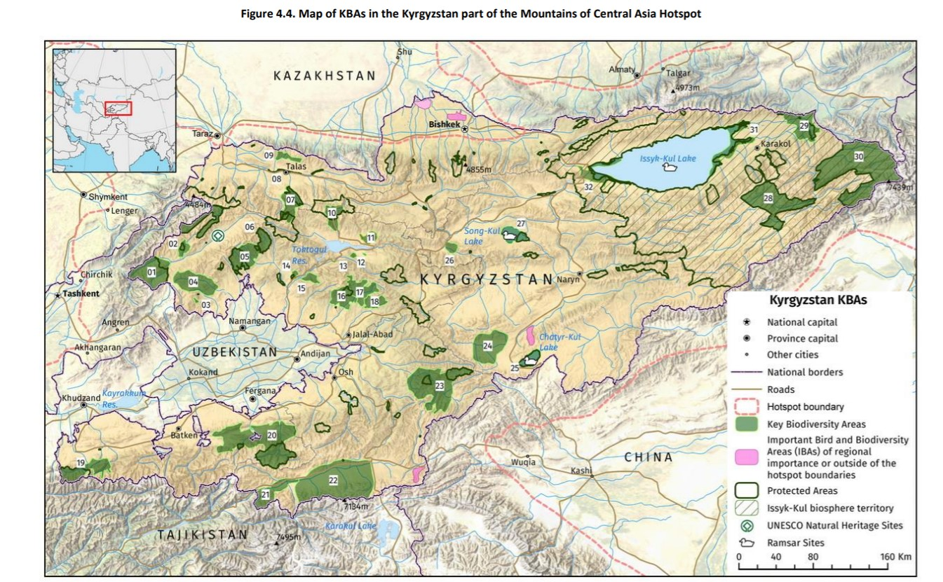

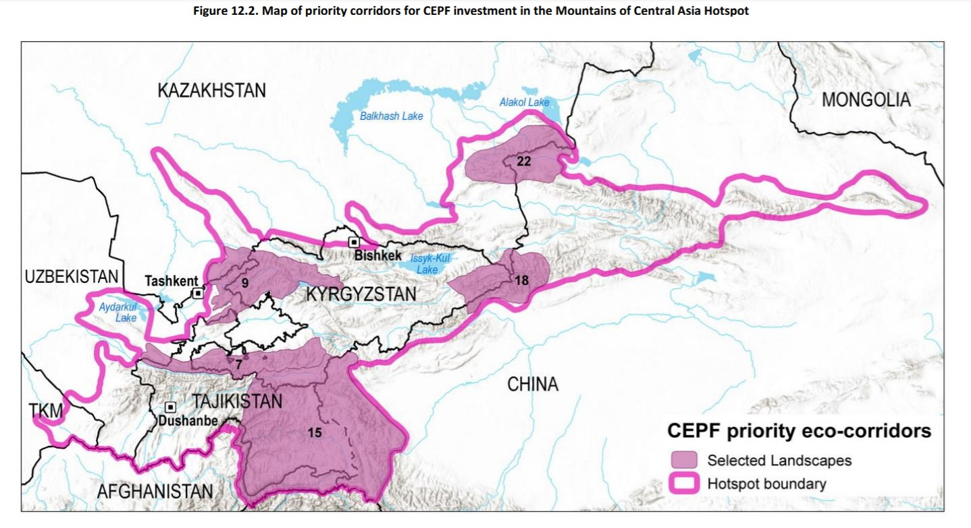

TIMEFRAME

Projects are expected to start in 2020. Typical duration will be one to two years, but all CEPF-funded work must be complete by June 2024.

HOW TO APPLY

Applicants should complete proposals and budgets per the templates available at the Grantee Portal, www.mca.earth.

Proposals can be written in English or Russian.

Applicants must submit their completed proposal and budget by the deadline via electronic mail to:

Tatyana Reznikova, Small-Grants Manager, tatyana@argonet.org

Please copy the Mikhail Yakovlev, Kyrgyz Country Coordinator (mihey-painter@mail.ru.) in your message.

You will receive an acknowledgement from the RIT confirming your submission.

The review process will take approximately 6 weeks from the deadline date. The review committee will select the strongest proposals which meet the eligibility criteria, as shown in the Expert Evaluation Form.

Selected proposals will be awarded a small grant, with an agreement made between WWF Central Asia as the RIT for the Mountains of Central Asia Hotspot, and the applicant’s institution (the “Grantee”). We reserve the right to request that the Grantee make changes to the project and planned activities, should such changes be recommended by our panel of experts. Grants will be denominated in United States dollars and grant agreements will be in English or Russian. A sample Grant agreement letter can be found on the Grantee Portal at www.mca.earth.

REFERENCE MATERIALS

All applicants are advised to review the CEPF Ecosystem Profile for the Mountains of Central Asia, which serves as the strategy document for CEPF investment in the Hotspot and provides more detail on the types of activity CEPF will fund under each Investment Priority.

- Ecosystem Profile: English, Russian
- Ecosystem Profile Summary: English, Russian

CEPF is committed to integrating gender into its portfolio. Applicants should design projects and write proposals that consider gender issues in the achievement of their conservation impacts. CEPF has developed several resources that can help applicants to design, implement and evaluate gender-aware projects (CEPF Gender Toolkit) and understand what CEPF seeks in a proposal (CEPF Gender Fact Sheet). Visit the CEPF and Gender webpage to learn more about how CEPF addresses gender in the projects it supports. CEPF will evaluate your project based on its integration of gender.

All projects must be in line with the Safeguard policies. They can be found here, and on the Grantee Portal.

Additional resources:

- Before You Apply
- 12 Tips for Getting Your Grant Idea Funded
- CEPF Project Database
- Life Cycle of a Grant

CONTACT

Before submitting your letter of inquiry, we encourage you to discuss your eligibility and project idea with us. Please contact:

- Mikhail Yakovlev, +996 708 148 015, mihey-painter@mail.ru
- Tatyana Reznikova, Small-Grants Manager: tatyana@argonet.org
- Lizza Protas, RIT Team Leader: lprotas@wwf.ru

